**Inventor To M2k User Testing**

Task 1:

1. Draw this parts and put them into an assembly named **NRL-4441**

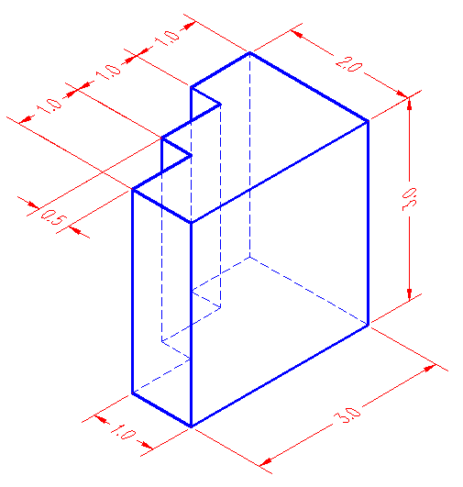

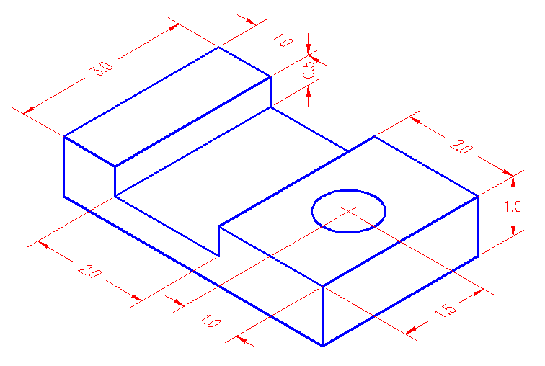

*Use Inventor Auto generated numbers.*

1. Using the **Import Info Button**, Before putting them into an assembly, create the following information:
   1. Item Master Information
   2. Bill of Material
   3. Routing information
2. Put into an assembly and create the same information for the assembly (**NRL-4441**)